## Front End Engineering-II

Project Report

Semester-IV (Batch-2022)

**Palindrome Checker**

**Supervised By: Submitted By:**

Raveesh Samkaria Sneha Miglani

Roll Number: -2210990858

Group - 13

**Department of Computer Science and Engineering**

## Chitkara University Institute of Engineering & Technology,

## Chitkara University, Punjab

**Abstract**

A simple online tool called WebTools Palindrome Checker can be used to determine if a given string is a palindrome. This project, which was created with HTML, CSS, Bootstrap, and JavaScript, provides users with an easy-to-use interface that allows them to enter any string and quickly determine whether it is palindromic with just one click. To ensure accurate palindrome detection, the application takes into account a number of factors, including letter case, punctuation, and spaces. WebTools Palindrome Checker is a useful tool for language enthusiasts, writers, and web developers who want to use palindromes in their work because of its elegant layout and responsive design. This tool is a great way to learn about the world of palindromes and improve your language skills, whether you're creating clever wordplay or analyzing linguistic patterns.

窗体底端

窗体底端

**Table of Contents**

|  |  |  |
| --- | --- | --- |
| Sr.no | Section | Page No |
| 1. | Introduction | 4 |
| 2. | Problem Statement | 5 |
| 3. | Technical Details | 7 |
| 4. | File Structure | 8 |
| 5. | Result | 9 |
| 6. | References | 28 |

**Introduction**

The creation of effective and intuitive web tools has become crucial in the digital age, where innovation and technology meet. This is the background against which I set out to create the Palindrome Checker website, an endeavor that combines JavaScript, HTML, CSS, and Bootstrap to offer a smooth palindrome verification experience.

This project report explores the complexities of my work, providing a thorough explanation of the idea, layout, execution, and potential future developments of the Palindrome Checker website. Using a variety of front-end technologies, my goal was to provide a stable, user-friendly, and aesthetically pleasing platform that would enable users to quickly determine whether a string is palindromic.

In this report, I examine the thinking behind my design decisions, the difficulties we faced during development, and the creative ways we overcame those difficulties. I also discuss the iterative approach that advanced the project and emphasize the work done to accomplish the goals.

I encourage readers to immerse themselves in the process of developing the Palindrome Checker website as we go through the report's pages, from the idea to the finished product—a useful online application. I hope that this paper will serve as evidence of how technology can be used to solve practical issues and spur further advancements in web development.

**Problem Statement**

Innovation in web development is fueled by the development of effective and user-friendly solutions to common issues. Verifying palindromes, or strings that read the same both forward and backward regardless of spaces, punctuation, or capitalization, is one such issue.

In order to solve this issue, the Palindrome Checker website project offers users an easy-to-use platform to confirm whether or not a given string is a palindrome. The project's goal is to create a reliable solution that is usable by a broad spectrum of users by utilizing the capabilities of HTML, CSS, JavaScript, and Bootstrap.

The fact that palindromes are so common in language, math, and computer science among other fields, makes a palindrome checker necessary. The ability to quickly and accurately identify palindromes is invaluable in a variety of contexts, including creative writing, linguistic puzzles, and data validation.

The project aims to simplify palindrome verification by creating an intuitive web application that can be used by users of various backgrounds and abilities. Users will be able to enter any string into the website's user-friendly interface and get immediate feedback on whether or not it is palindromic.

When tackling this issue, important factors to take into account are:

* ensuring palindrome detection accuracy by taking into account elements like punctuation, spaces, and letter case.
* creating a user interface that is simple to use and comprehend.
* making the website as accessible and responsive as possible on a range of screens and devices.
* putting strong error handling in place to give users instructive feedback when errors or invalid inputs occur.

The overall goal of the Palindrome Checker website project is to give users a useful tool for quickly and accurately verifying palindromes, thereby advancing web development and problem-solving skills in the digital world.

**Light Mode**

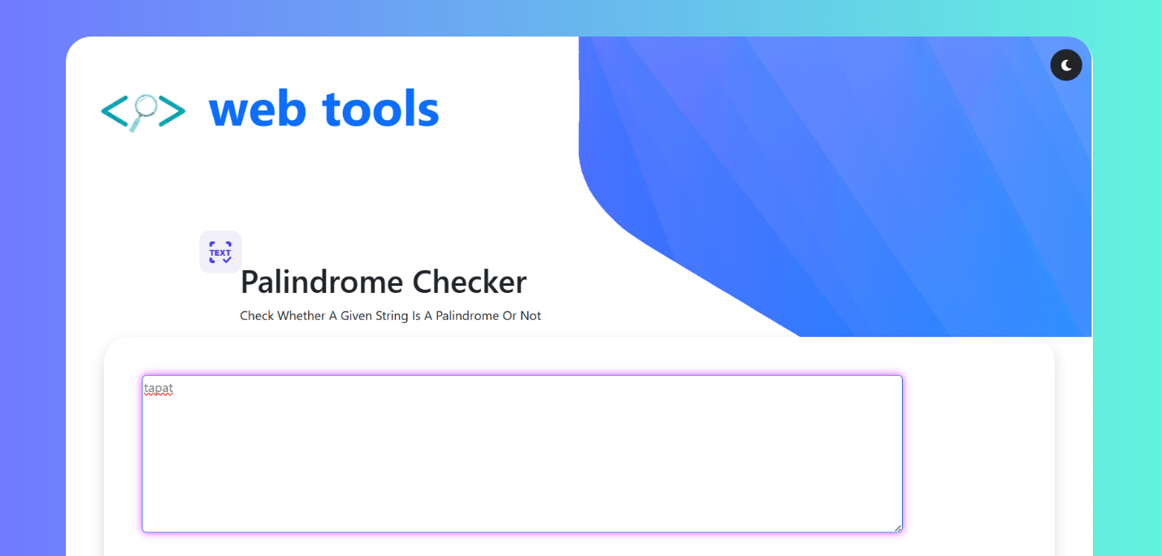

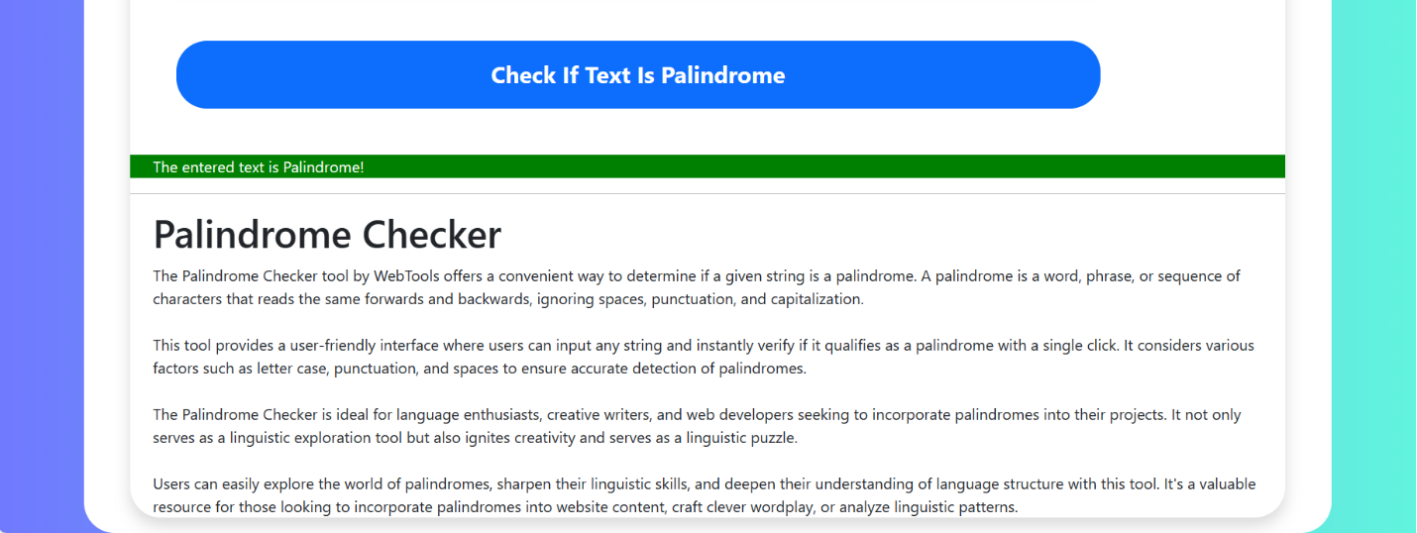

**Dark Mode**

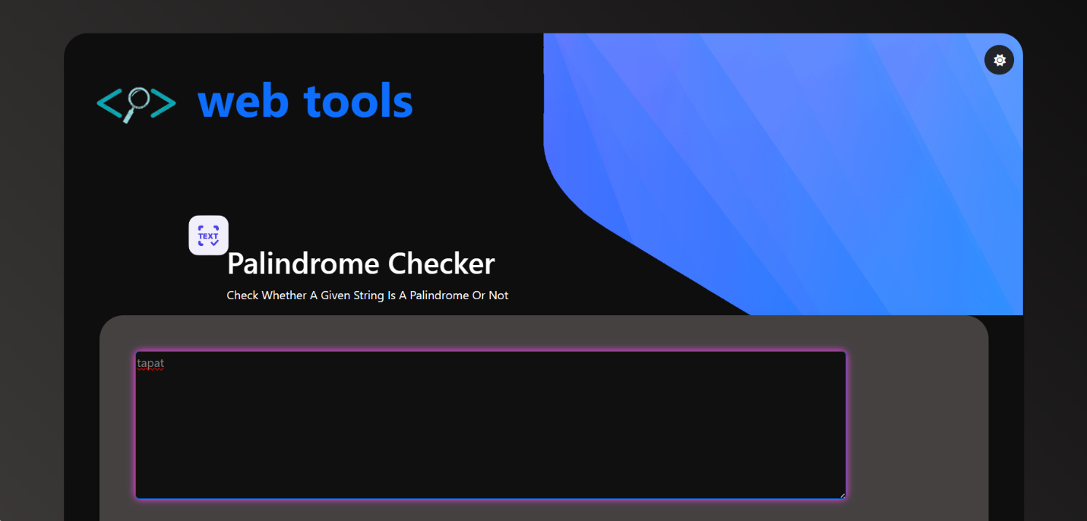

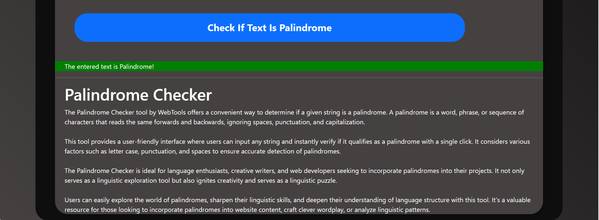

**Technical Details**

The front-end website for the Palindrome checker website was meticulously crafted with a minimalist approach, focusing on essential technologies to deliver a seamless and visually appealing user experience. Here are the key technical details of the project:

1. **HTML Structure**: The foundation of the website was built using semantic HTML markup, enhancing accessibility and clarity for visitors. Each menu page was structured with appropriate tags to facilitate intuitive navigation and readability, ensuring that customers can easily explore the diverse offerings of the restaurant.
2. **CSS Styling:** Cascading Style Sheets (CSS) played a pivotal role in styling the layout, typography, and color schemes of the menu website. Custom CSS rules were meticulously applied to maintain a cohesive visual design throughout the site, while also prioritizing optimized load times and code simplicity to enhance performance.
3. **Bootstrap Integration:** The Bootstrap framework is employed to streamline the development process and enhance the responsiveness of the website. Bootstrap's prebuilt CSS components and JavaScript plugins are utilized to implement features such as the navbar, buttons, forms, and responsive grid layout. This allows for rapid development and ensures a consistent and polished appearance across different devices and screen sizes. Bootstrap's grid system is particularly instrumental in creating a responsive layout that adapts seamlessly to various viewport sizes.
4. **JavaScript Functionality:** JavaScript (JS) is utilized to add interactivity and dynamic behavior to the website. JS code is implemented to enable functionality such as color selection, gradient generation, dark mode toggle, and random color/gradients buttons. Event listeners are employed to detect user interactions and trigger corresponding actions, enhancing the user experience and providing intuitive controls for customizing the background color palette. Additionally, JS is used to dynamically update the color display text and manage the visibility of certain elements based on user actions, contributing to a seamless and engaging browsing experience.

**File Structure: -**

1. **index.html:** Serving as the central entry point, this HTML file outlines the structure and content of the web pages. It encompasses sections like the header, navigation bar, main content area, footer, and any additional elements necessary for a cohesive user experience.
2. **custom.css:** This CSS file houses the styling rules governing the visual presentation of the website. It includes directives on colors, fonts, layout properties, and other stylistic elements, ensuring a consistent and visually appealing design across the site. Both general styling and responsive design considerations are encapsulated within this file.
3. **custom.js:** The script.js file contains JavaScript code that adds interactivity and dynamic functionality to the website. It handles tasks such as color selection, gradient generation, dark mode toggling, and other user interactions. By implementing event listeners and DOM manipulation, this file enhances the user experience and adds depth to the website's functionality.
4. **Images:** This folder contains all the images which are used in this project

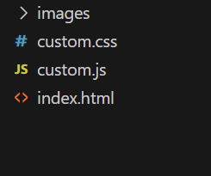

**Result -** Web-page Screenshots: -

**Desktop View-**









**Mobile View-**

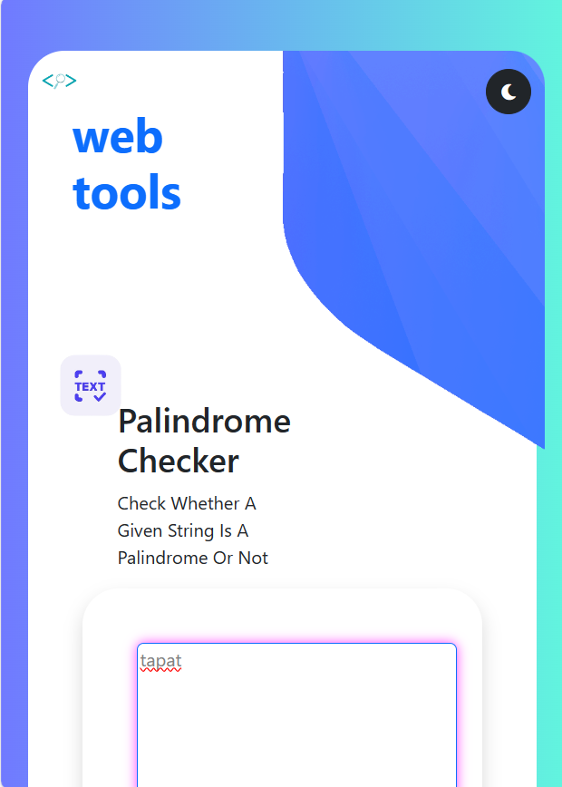

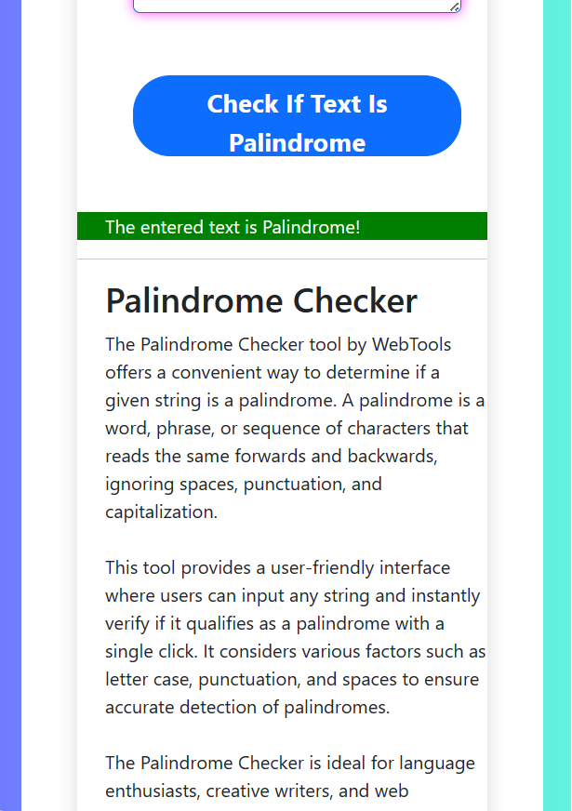

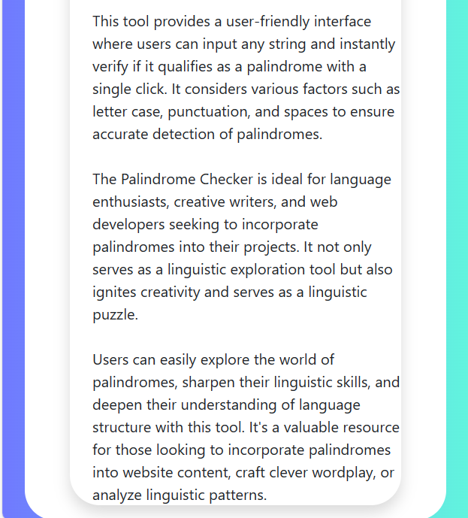

**Code:-**

***Figure 1 HTML - head tag***

<!DOCTYPE html>

<html lang="en">

<head>

  <meta charset="UTF-8">

  <meta name="viewport" content="width=device-width, initial-scale=1.0">

  <!-- Bootstrap CSS -->

  <link href="https://cdn.jsdelivr.net/npm/bootstrap@5.3.3/dist/css/bootstrap.min.css" rel="stylesheet" integrity="sha384-QWTKZyjpPEjISv5WaRU9OFeRpok6YctnYmDr5pNlyT2bRjXh0JMhjY6hW+ALEwIH" crossorigin="anonymous">

  <!-- Custom CSS -->

  <link rel="stylesheet" href="custom.css">

  <!-- Font Awesome CSS -->

  <link rel="stylesheet" href="https://cdnjs.cloudflare.com/ajax/libs/font-awesome/6.0.0-beta3/css/all.min.css"> <!-- For icons -->

  <title>Document</title>

</head>

**Figure 2 HTML – Bootstrap CSS CDN links**

<!-- Bootstrap CSS -->

  <link href="https://cdn.jsdelivr.net/npm/bootstrap@5.3.3/dist/css/bootstrap.min.css" rel="stylesheet" integrity="sha384-QWTKZyjpPEjISv5WaRU9OFeRpok6YctnYmDr5pNlyT2bRjXh0JMhjY6hW+ALEwIH" crossorigin="anonymous">

  <!-- Custom CSS -->

  <link rel="stylesheet" href="custom.css">

  <!-- Font Awesome CSS -->

  <link rel="stylesheet" href="https://cdnjs.cloudflare.com/ajax/libs/font-awesome/6.0.0-beta3/css/all.min.css"> <!-- For icons -->

**Figure 3 HTML – Logo Column And Title Column**

 <!-- Logo Column -->

              <div class="col-2">

                <img class="img" width="100%" src="images/logo.png"  alt="">

              </div>

              <!-- Title Column -->

              <div class="col-4 mt-5">

                <p class="text-primary h1 fw-bold display-3 text-left">web tools</p>

                <img class="textimage mt-4" src="images/text.png" height="80px" alt="">

                <p class="h1 mt-5">Palindrome Checker

                  <p>Check Whether A Given String Is A Palindrome Or Not</p>

                </p>

              </div>

***Figure 4 HTML - dark-light mode***

<div class="col-6 bg-image d-flex justify-content-end align-items-start" style="border-top-right-radius: 30px;">

                <button id="modeToggle" class="btn btn-dark mode-toggle rounded-circle mt-3 mr-3" style="height: 40px; width: 40px;"><i class="fas fa-moon"></i></button>

**Figure 5 HTML – Text Area And CheckButton Container**

  <!-- Text Area and Button Container -->

              <div class="container">

                <div class="row px-5 ">

                  <div class="col-12">

                    <!-- Contents Container -->

                    <div class="contents shadow rounded-5">

                      <!-- Text Area -->

                      <textarea id="textInput" class="rounded border border-primary m-5" style="width: 80%; height: 200px; color: grey;" placeholder="Your text here">Your text here</textarea>

                      <!-- Check Button -->

                      <button id="checkButton" type="button" class="btn btn-primary ms-5  rounded-5 fw-bold fs-4" style="height:70px; width: 80%;" onclick="checkPalindrome()">Check If Text Is Palindrome</button>

                      <!-- Result Text -->

                      <p id="resultText" class="ps-4 mt-5"></p>

                      <hr>

***Figure 6 HTML - Palindrome Checker Definition And Description***

<!-- Palindrome Checker Description -->

                      <p class="h1 ps-4">Palindrome Checker

                        <p class="ps-4">The Palindrome Checker tool by WebTools offers a convenient way to determine if a given string is a palindrome. A palindrome is a word, phrase, or sequence of characters that reads the same forwards and backwards, ignoring spaces, punctuation, and capitalization. <br>

                           <br>

                          This tool provides a user-friendly interface where users can input any string and instantly verify if it qualifies as a palindrome with a single click. It considers various factors such as letter case, punctuation, and spaces to ensure accurate detection of palindromes. <br>

                          <br>

                          The Palindrome Checker is ideal for language enthusiasts, creative writers, and web developers seeking to incorporate palindromes into their projects. It not only serves as a linguistic exploration tool but also ignites creativity and serves as a linguistic puzzle. <br>

                          <br>

                          Users can easily explore the world of palindromes, sharpen their linguistic skills, and deepen their understanding of language structure with this tool. It's a valuable resource for those looking to incorporate palindromes into website content, craft clever wordplay, or analyze linguistic patterns.</p>

                      </p>

                    </div>

                  </div>

                </div>

              </div>

***Figure 7 HTML - Background Container and Main content***

<div class="container-fluid background">

    <div class="container">

      <!-- Main Content Row -->

      <div class="row min-vh-100">

        <div class="col-12">

          <!-- Content Container -->

          <div class="content rounded-5 mt-5">

            <!-- Logo and Title Row -->

            <div class="row min-vh-100">

              <!-- Logo Column -->

              <div class="col-2">

                <img class="img" width="100%" src="images/logo.png"  alt="">

              </div>

              <!-- Title Column -->

              <div class="col-4 mt-5">

                <p class="text-primary h1 fw-bold display-3 text-left">web tools</p>

                <img class="textimage mt-4" src="images/text.png" height="80px" alt="">

                <p class="h1 mt-5">Palindrome Checker

                  <p>Check Whether A Given String Is A Palindrome Or Not</p>

                </p>

              </div>

              <!-- Toggle Button Column -->

              <div class="col-6 bg-image d-flex justify-content-end align-items-start" style="border-top-right-radius: 30px;">

                <button id="modeToggle" class="btn btn-dark mode-toggle rounded-circle mt-3 mr-3" style="height: 40px; width: 40px;"><i class="fas fa-moon"></i></button>

              </div>

              <!-- Text Area and Button Container -->

              <div class="container">

                <div class="row px-5 ">

                  <div class="col-12">

                    <!-- Contents Container -->

                    <div class="contents shadow rounded-5">

                      <!-- Text Area -->

                      <textarea id="textInput" class="rounded border border-primary m-5" style="width: 80%; height: 200px; color: grey;" placeholder="Your text here">Your text here</textarea>

                      <!-- Check Button -->

                      <button id="checkButton" type="button" class="btn btn-primary ms-5  rounded-5 fw-bold fs-4" style="height:70px; width: 80%;" onclick="checkPalindrome()">Check If Text Is Palindrome</button>

                      <!-- Result Text -->

                      <p id="resultText" class="ps-4 mt-5"></p>

                      <hr>

                      <!-- Palindrome Checker Description -->

                      <p class="h1 ps-4">Palindrome Checker

                        <p class="ps-4">The Palindrome Checker tool by WebTools offers a convenient way to determine if a given string is a palindrome. A palindrome is a word, phrase, or sequence of characters that reads the same forwards and backwards, ignoring spaces, punctuation, and capitalization. <br>

                           <br>

                          This tool provides a user-friendly interface where users can input any string and instantly verify if it qualifies as a palindrome with a single click. It considers various factors such as letter case, punctuation, and spaces to ensure accurate detection of palindromes. <br>

                          <br>

                          The Palindrome Checker is ideal for language enthusiasts, creative writers, and web developers seeking to incorporate palindromes into their projects. It not only serves as a linguistic exploration tool but also ignites creativity and serves as a linguistic puzzle. <br>

                          <br>

                          Users can easily explore the world of palindromes, sharpen their linguistic skills, and deepen their understanding of language structure with this tool. It's a valuable resource for those looking to incorporate palindromes into website content, craft clever wordplay, or analyze linguistic patterns.</p>

                      </p>

                    </div>

                  </div>

                </div>

              </div>

            </div>

          </div>

        </div>

      </div>

    </div>

  </div>

***Figure 8 HTML - Bootstrap JS CDN links***

<!-- Bootstrap js -->

  <script src="https://cdn.jsdelivr.net/npm/@popperjs/core@2.11.8/dist/umd/popper.min.js" integrity="sha384-I7E8VVD/ismYTF4hNIPjVp/Zjvgyol6VFvRkX/vR+Vc4jQkC+hVqc2pM8ODewa9r" crossorigin="anonymous"></script>

  <script src="https://cdn.jsdelivr.net/npm/bootstrap@5.3.3/dist/js/bootstrap.min.js" integrity="sha384-0pUGZvbkm6XF6gxjEnlmuGrJXVbNuzT9qBBavbLwCsOGabYfZo0T0to5eqruptLy" crossorigin="anonymous"></script>

  <!-- Custom JavaScript -->

  <script src="custom.js"></script>

***Figure 9 CSS Code***

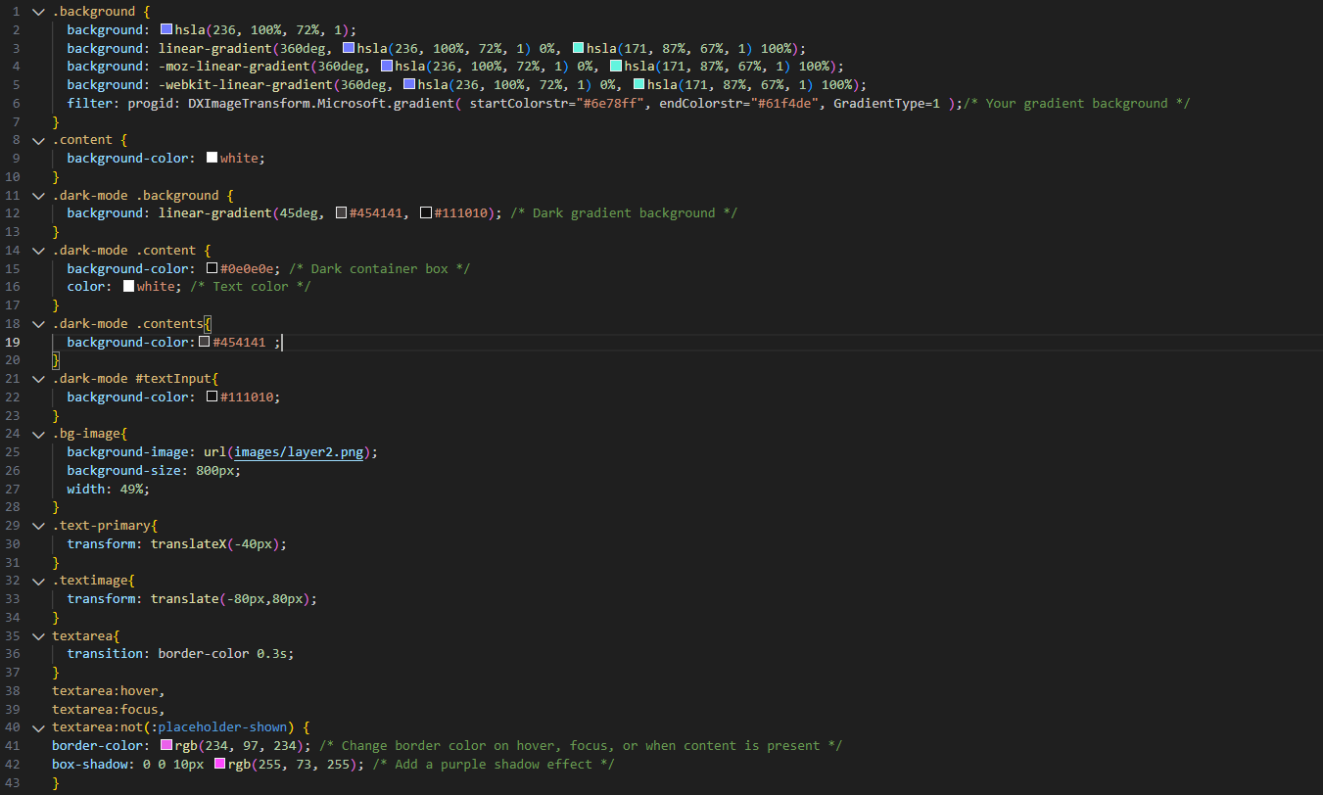

***Figure 10 JavaScript Code***

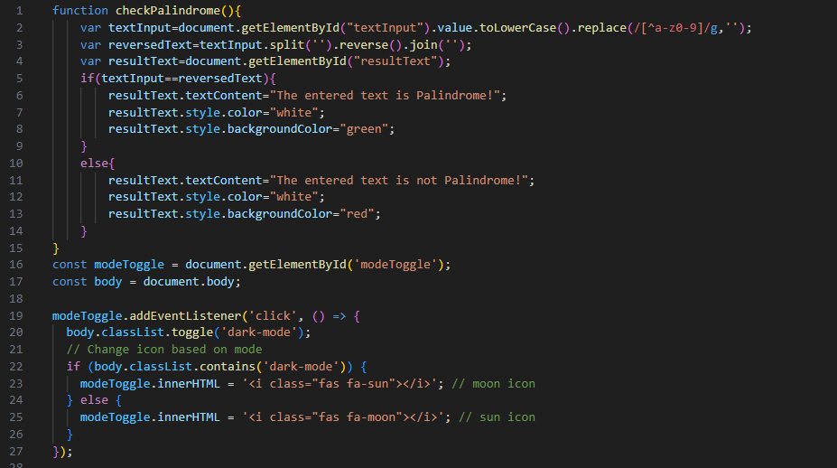

**References**

1. [www.photopea.com](http://www.photopea.com)

For creating template before building website

1. [www.w3schools.com](http://www.w3schools.com)
2. <https://getbootstrap.com/docs/5.3/getting-started/introduction/>

Used this website for understanding bootstrap classes

1. <https://fonts.google.com/>
2. <https://wtool.dev/public/>